How and where do I upload a Birth Certificate - Document Repository – GotSport (zendesk.com)

How and where do I upload a Birth Certificate - Document Repository
This article will show you how and where to upload a birth certificate to a user's profile

IMPORTANT NAVIGATION INSTRUCTIONS
Documents must be added to the specific player profile under their forms section. Typically, parents will be accessing the system through their OWN user account login and NOT their child's profile. To find your associated family members, you will click "Account" in the top menu bar. Next click on "Family" in the left navigation bar. Click into the specific player and follow the instructions below:

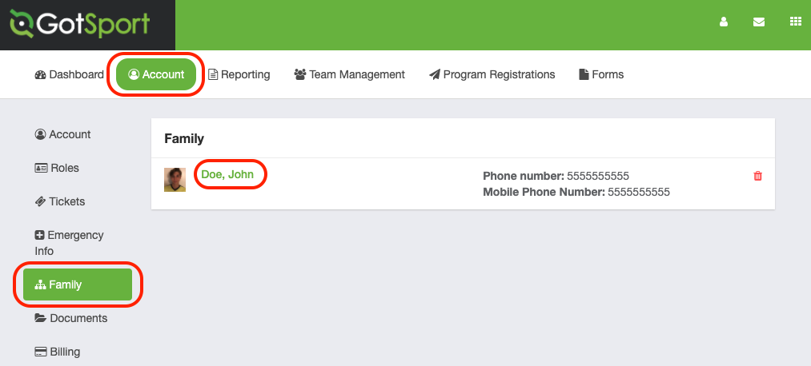
Step One: Click the "Documents" tab over on the left.
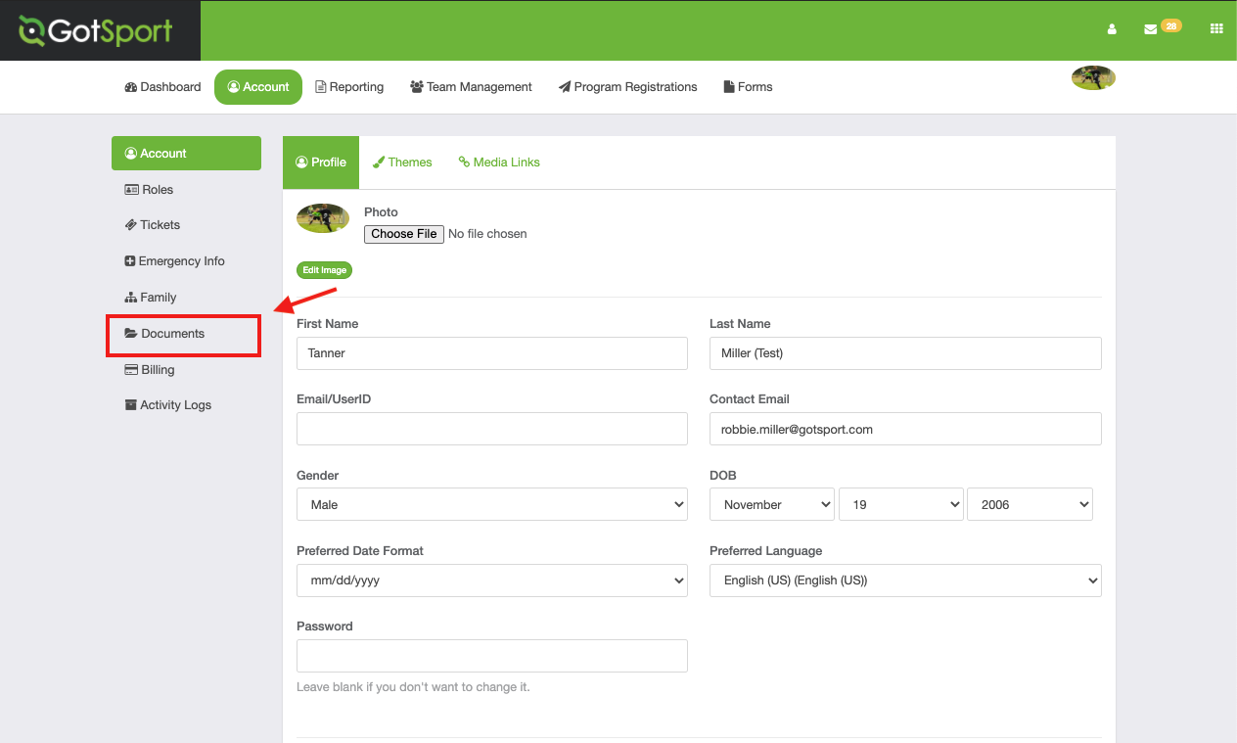
Step Two: Click "New Document"
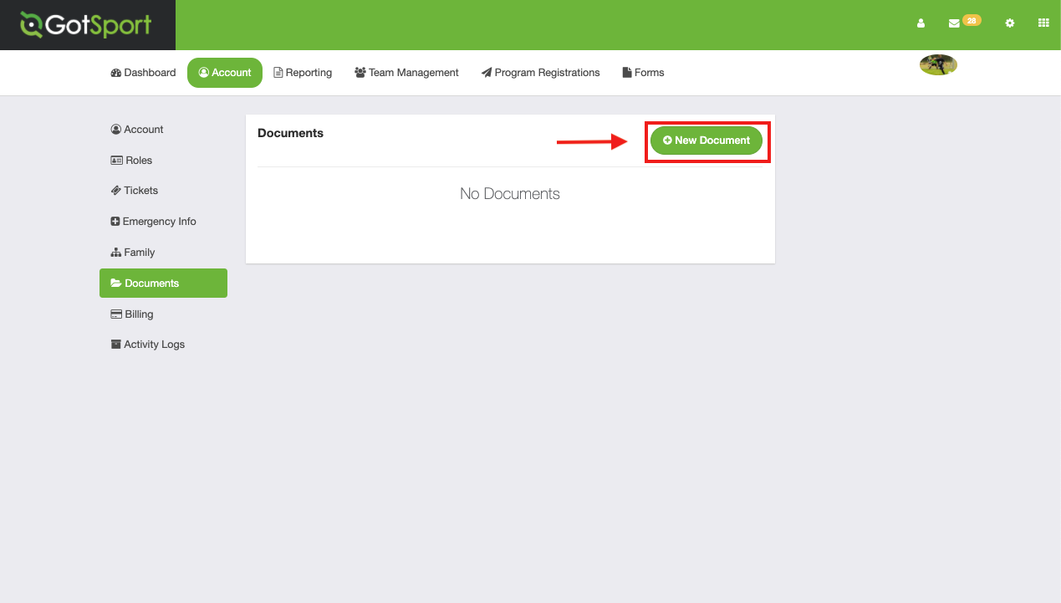
Step Three: Select "Birth Certificate" in Document Repository and click "Go".
NOTE - if you do NOT see Birth Certificate as an option it means your Organization has not created a document repository for birth certificates - please contact them and ask to them to create one.
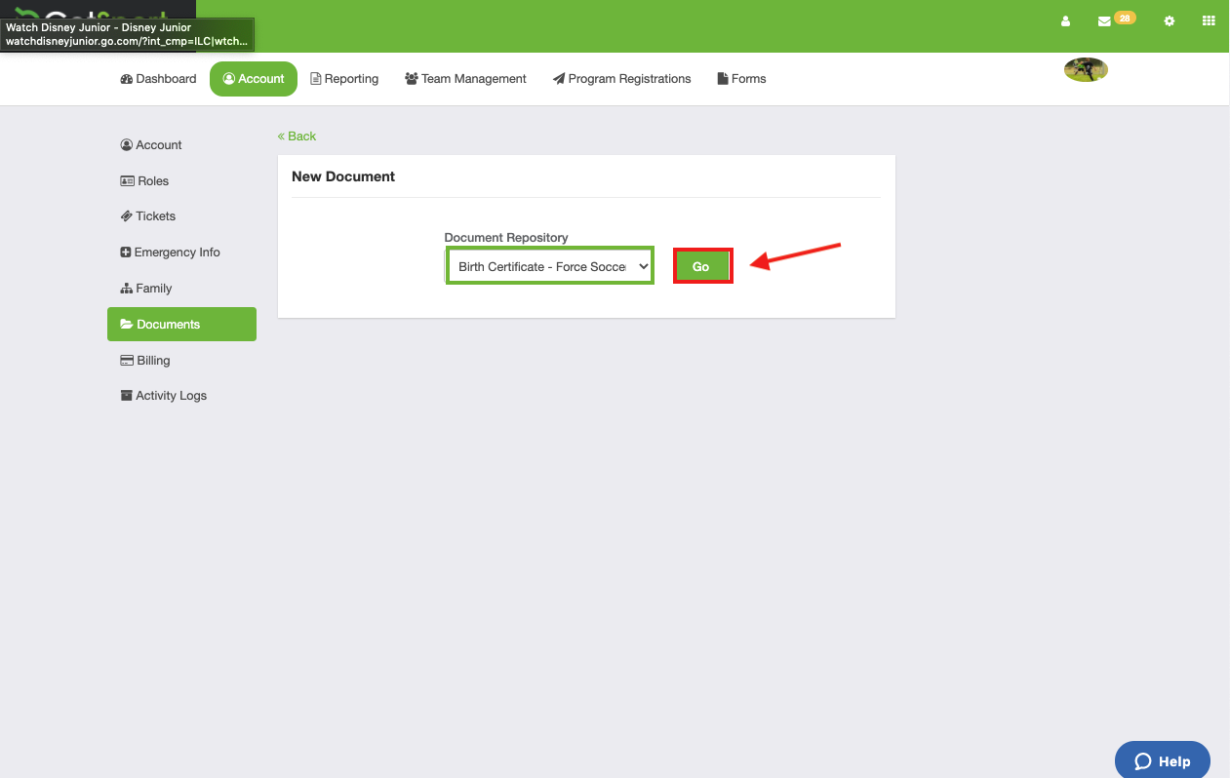
Step Four: Upload the file and click "Save".
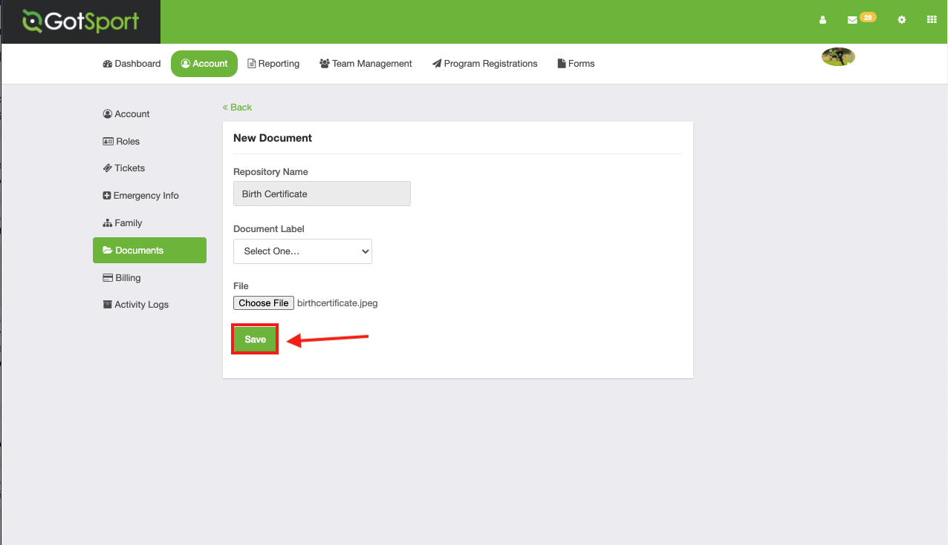

Troubleshooting
Having issue uploading a document?
- Receiving an error message:
  - Make sure the document is not too large. The system will only accept documents under 3mb.

