Pecan Grove 9/3
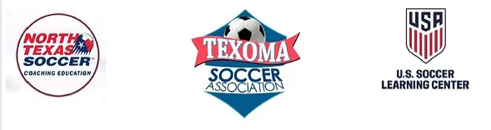
TEXOMA SOCCER has partnered with NORTH TEXAS SOCCER and the U.S. SOCCER LEARNING CENTER to provide two Grassroots Coaching courses in Sherman September 2022. The courses will be 2 hours online and 2 hours in person, with offerings in 4v4 and 7v7 game models. The courses will focus on providing coaching education resources to current coaches and aspiring coaches in the game model of their choice.
WE would like to invite all local coaches or anyone interested in becoming a coach to attend the scheduled sessions. The focus will be on the increasing knowledge of basic coaching techniques, an introduction to tactics, skills, LAWS of the GAME as well as identifying the best practices for player development and practice structures.
In person Field session Saturday 9/3 Pecan Grove Park West 3200 Canyon Creek Dr Sherman TX 75092
Contact: Javier Perdomo, North Texas State Soccer: javier@ntxsoccer.org
Texoma Soccer Contact: Caleb Smith, Director of Education: education@texomasoccer.org

